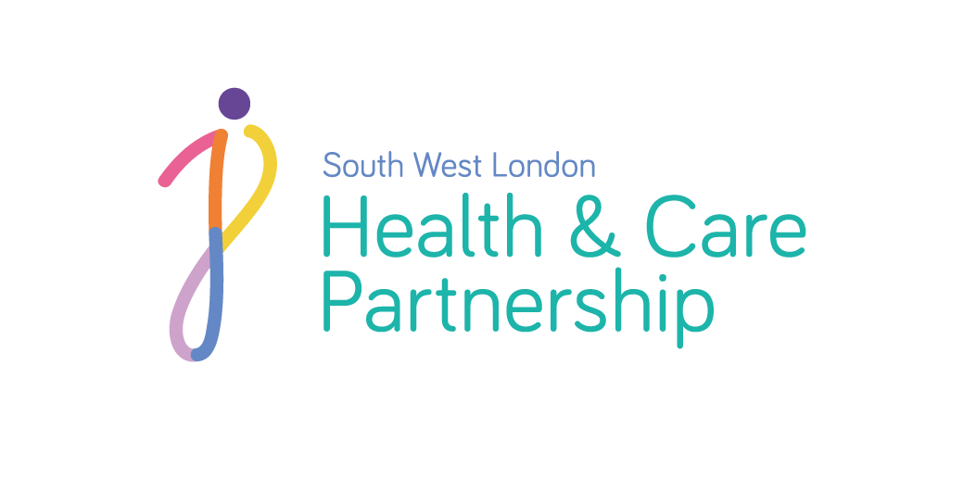
SWL EMHIP Delivery Group
www.swlondon.nhs.uk
We believe in an inclusive and innovative approach to care.

Terms of Reference

- Role/Purpose

Ethnicity and Mental Health Improvement Programme (EMHIP) is an ‘Inside-Outside’ project co-produced and co-led by SWL HCP, SWLSTG and the Wandsworth Community Empowerment Network, in partnership with other key SWL partners (e.g. Public Health, local community and charities).

This is a SWL HCP programme, with an initial pilot in Wandsworth

The next phase of EMHIP will deliver the Wandsworth BME Expert Panel’s recommendation to implement the 5 Key EMHIP interventions including monitoring and evaluation of outcomes.

- Aims

The SWL EMHIP Delivery Group aims to perform the following key activities in coordination with SWL system partners:

- Establish Programme Governance and reporting to the SWL Mental Health Transformation Programme Board;
- Provide support for the development, approval, implementation, delivery and oversight of the EMHIP business case.
- Develop implementation plans for sustainable delivery of EMHIP in Wandsworth, wider cultural change and improvement across South West London

- Objectives and Commitments

- Ensure that this group has the appropriate SWL senior-level support to deliver the programme aims (e.g. clinical, financial, commissioning, etc.), and co-opt members if necessary
- Develop and finalise the EMHIP business case
  - Review all interventions with a view to integrating service redesign as a core concept and aligning with existing local community-based services
  - Establish the financial and other service costs and benefits of the business case
  - Ensure the project is co-produced and all interventions are guided by the lived experience of people using mental health services in SWL
  - Agree business case Key Performance Indicators, including those related to process, outcome measures and VfM.
  - Establish the wider SWL impacts of the business case, including statutory obligations, procurement requirements, clinical and information governance, system performance targets, NHS quality measures, etc.
- Review the wider impacts of business case and projects. This includes statutory obligations, procurement requirements, performance requirements and quality implications.
- Agree and manage the phased implementation of EMHIP across SWL - develop and further refine the priorities for the project and ensure the commitment of all organisations to achieve a transformed, improved, and affordable service.
- Programme delivery oversight (e.g. review and challenge of implementation and delivery, ongoing assessment and reporting of progress to SWL MH Transformation Programme Board, other SWL HCP Programmes and other SWL partners, SWL local BME communities, etc.

- Work Programme Structure

Between November and the end of March 2021 the EMHIP delivery group will focus on:
  - Enhance the EMHIP BC in preparation to go through the SWL formal governance process
  - Survey and maximise opportunities for wider funding
  - Develop project plans for sustainable implementation

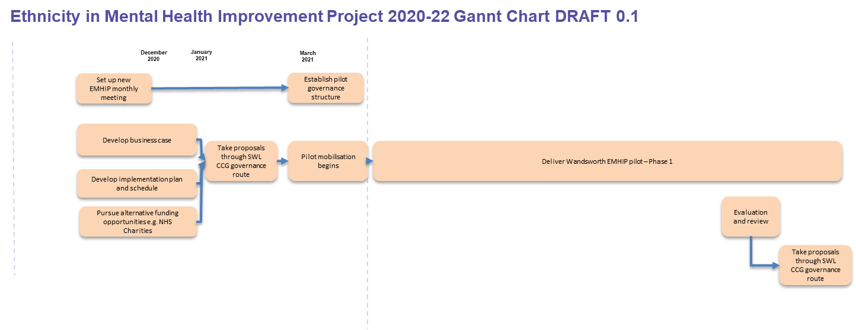

- Term

The EMHIP Delivery Group will continue until April 2022, the completion of Wandsworth Pilot.

SWL Mental Health Transformation Board can terminate the Group by agreement once alternative governance arrangements are devised and agreed by the Group.

- Meeting Arrangements and Frequency
The EMHIP Delivery Group will meet monthly chaired by Wandsworth CCG MH Clinical lead (Dr Tom Coffey) who, with support from SWL CCG, will oversee the co-ordination and servicing of the meeting.
A schedule of meetings will be circulated to Members of the Group.

- Project and meeting Support

- Funding for the project, administration support and meeting support will be provided by SWL HCP
- The agenda will be pre-agreed with the Chair
- The meeting agenda and supporting papers will be shared with the members of the group at least three working days ahead of the meeting
- Apologies will be sent in advance to the administrative support
- Minutes, notes and actions will be circulated within five working days of the meeting.

- Accountability

- The EMHIP Delivery Group will report directly into the SWL Mental Health Transformation Programme Board
- Members will be responsible for information sharing between the group and their organisations
- Confidential items will be clearly identified at the meeting and in the notes and action points. All conflicts of interest must be declared.

Please see below, for the EMHIP Delivery Group Governance.

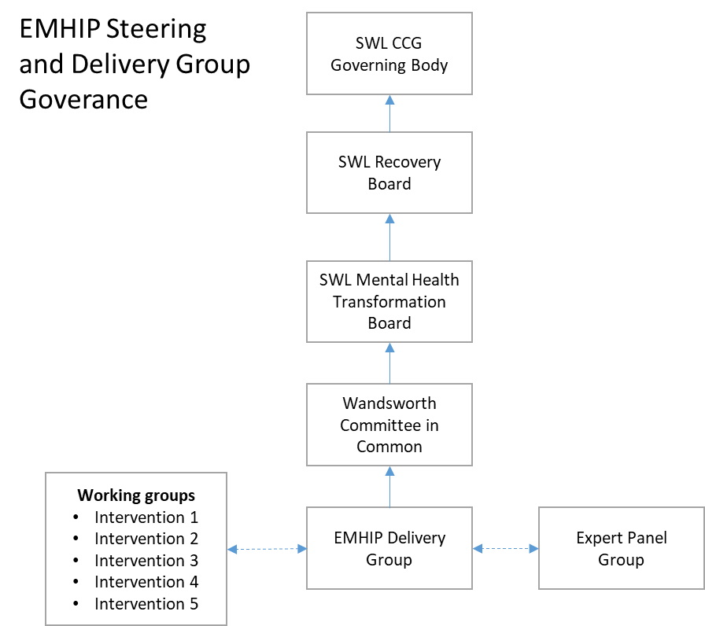

- Membership

Name | Title | Organisation | PC Board Role
Dr. Tom Coffey | MH Clinical Lead, GP | M&W SWL CCG | Chair and Clinical Lead
Mark Creelman | Executive Locality Director | M&W SWL CCG | Member & SRO
Gemma Dawson | Head of Projects and Strategy | M&W SWL CCG | Project Manager & Co-Convenor
Malik Gul | Director | WCEN | Project Lead & Co-Convenor
John Atherton | MH Transformation Director | SWL HCP | Member
Michelle Woodward | MH Transformation Deputy Director | SWL HCP | Member
Mike Procter | Director of Transformation | M&W SWLCCG | Member
Bishop Delroy Powell | Senior Pastor | New Testament Assembly/Faith Groups | Member
Sashi Sashidharan | Professor | Independent | Project Consultant
Melba Wilson | Independent | Expert Panel | Member
Mark Robertson | MH Transformation Manager | M&W SWL CCG | Member
Jennifer Sinnott | Deputy Director Finance | M&W SWL CCG | Finance Member
Charlotte Harrison | Medical Director | SWLSTG | Member
tbc | Deputy Chief Operating Officer | SWLSTG | Member
tbc | Adult Care & Public Health | WBC | Member
Kalu Obuka | Head of Patient and Public Involvement & Equalities | M&W CCG | Member
Jayne Thorpe | Deputy Director Transformation (Pop Health, Prevention, LTCs, Communities & Equalities) | SWL HCP | Member
Dr Colin King | Service User Representative | Independent | Member

- In attendance by invitation
External organisations and/or representatives will be invited as and when required to provide relevant expertise, support the work and share good practice.

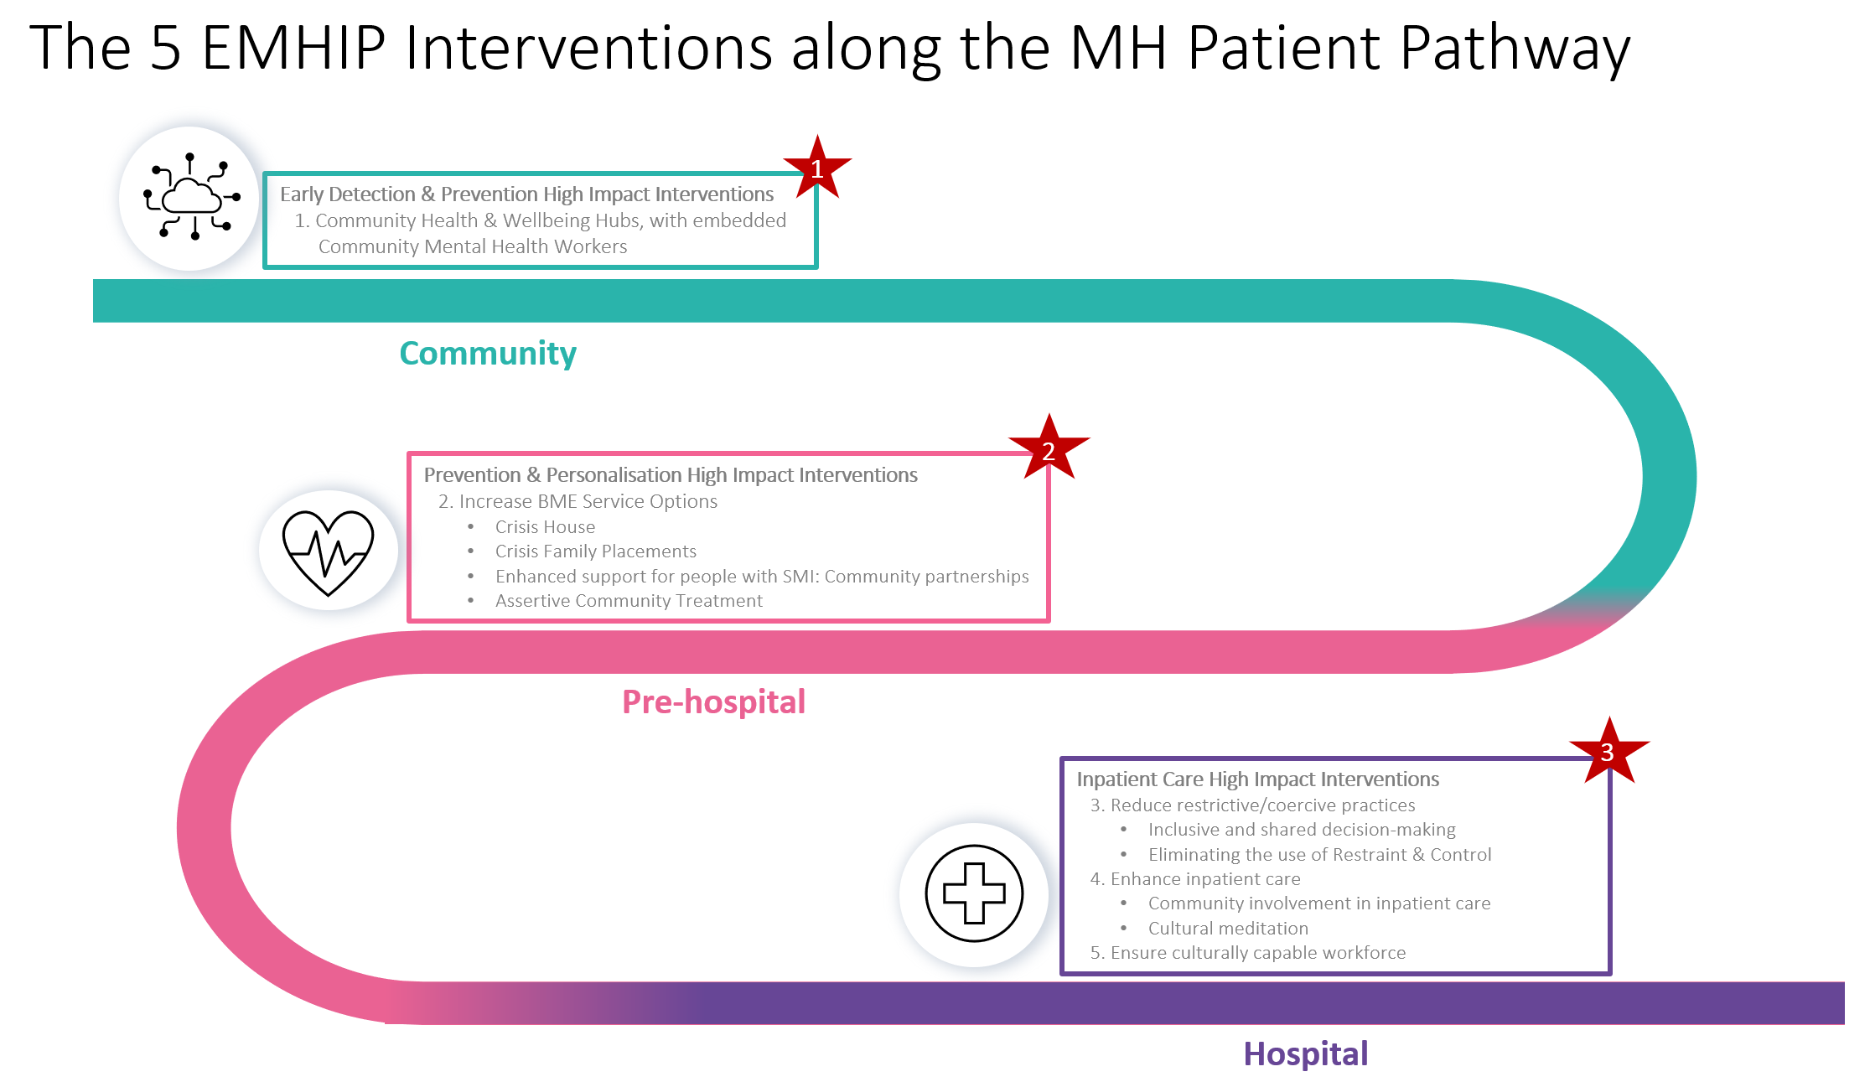

Appendix 2: EMHIP: Implementation work steams and work groups

Business case development:

- The first phase of the implementation of Ethnicity and Mental Health Improvement Project (EMHIP) Wandsworth (one-year pilot).
- This will involve: (i) refinement and detailed specification of the 5 Key Interventions (iii) ensuring fit purpose at each delivery point / system (ii) delivery / implementation across Wandsworth (iii) adaptation, improvement and fine-tuning as part of implementation process.
- Programme implementation will be driven through 5 Key Work Streams aligned to the EMHIP 5 Key Interventions, each supported by a Work Group.
- The Work Groups will have expertise of front-line clinicians, clinical and information governance, finance, business intelligence, transformation, local BME communities, service users and external experts
- EMHIP implementation will be underpinned and tethered to a common framework that will ensure and sustain (i) program‐practice fit (ii) leadership and training investment, (iii) organisational culture (iv) clinical innovations and (v) time and resources available for practice implementation

The five Key Interventions (KIs) will comprise of a number of changes in service organisation, staffing, service delivery practice and related clinical innovations. Five work streams are suggested, one for each KI.

- Mental Health and Wellbeing Hubs
- Commission and set up community-based Mental Health & Wellbeing Hubs
- Relocate /share some of the existing clinical services and resources from SPA, CMHT and PCP to the Hubs
- Enhance / supplement existing care pathway in relation to access and reverse access and ensure community support
- Out-reach work and integration / collaboration with other services and community assets
- Capacity and capability building in community agencies to manage and deliver the Hubs

- Increasing Choice and Plurality
2.1. Crisis residential alternatives: Crisis House and Crisis Family Placement
- Integration with CRHT service and align with crisis and acute acre pathway including acute wards
- Identify BME community partners for both
- Clinical service specification crisis House / crisis family placement

2.2. SMI service for BME long-term service users
- Identify community partner
- Capacity and capability building - community partner to manage and deliver the service
- Service and clinical specification
- Overlap with CMHT / care co-ordinator /tier 2 CPA
- Integration with physical health resources - community health, primary care
- Community based recovery resources and mobilisation of community assets, for e.g. Individual Placement and Support (ISP), personal budget etc.
- Micro area mental health investment and support

2.3. Culturally adapted AOT
- Service specification as pear ACT model and AOT experience
- Adaptation and enhancement for bespoke BME service (African and African Caribbean men)
- Collaborative networks: police, criminal justice system, substance misuse, pro-recovery community assets
- Family networks
- Vocational rehabilitation and recovery

- Reducing Coercion
3.1 Inclusive and shared decision making
- Process and procedures
- Nominated Person scheme
- Operationalising shared decision making and integrating into routine clinical practice
- Training and support for NPs
3.2 Eliminating the use of Restraint & Control
- Aligning with London Cavendish Group and Burdett interventions at SWLSTG
- Revising and expanding the SUI policy
- Learning loop and service reorientation-

- Enhance Inpatient Care
4.1 Community involvement in inpatient care
- Align with Canerows
- Expand and diversify above - support + advocacy
- Link with chaplaincy and IMHA
- Family / carer presence in IP wards - re-orientating the clinical space

4.2 Cultural Mediation
- Agree sites - only inpatient wards?
- Service specification
- External consultancy
- Specific training and support

- Culturally Capable Workforce
- Overlap with WRES and other Trust equality schemes
- Align with PCREF work at SLAM
- Program development
- Involving BME staff group at SWLSTG
- Target groups - Trust wide or clinical staff?
- External consultancy - programme delivery

